B.Tech Program First Year

Course: Experiential Learning

Course Code: DA1001

## School management system

by

**Aditya Joshi**

(Reg. No: 219302415)

Under the guidance

of

**Dr. Nirmal Kumar Gupta**

**Associate Professor**

Department of IT, SCIT, Manipal University Jaipur, Jaipur (Raj.).

**Department of Information Technology**

**School of Computing & IT (SCIT)**

**Faculty of Engineering**

**Manipal University Jaipur, India**

07, 2022

# Certificate

This is to certify that the project titled **“School Management System”** is a record of the bona fide work done by **Aditya Joshi** (Reg No:219302415) submitted for the partial fulfilment of the requirements for the completion of the Experiential Learning (DA1001) course in the Department of Information Technology of Manipal University Jaipur, during the academic session March-July 2022.

|  |
| --- |
|  |
| Dr. Nirmal Kumar Gupta  Assciate Professor  Department of IT |

|  |
| --- |
|  |
| Dr. Pankaj Vyas  Head of Department  Department of IT |

**ABSTRACT**

This project on School Management System is a data management program which can be used for easier management of administrative information of various students with the help of Python and MySQL. This whole process can be achieved by using MySQL alone but with the help of a programming language, we can skip writing a lot of MySQL queries and save a lot of time.

We use a MySQL table called ‘school’ which stores all of our data.

The list of entries we can store in the table is

* Name
* Class
* Section
* Scholar No
* Fee Details
* Caution Money Details

With the help of Python, we can ask the user what type of manipulation he wants. Primarily, user gets 4 options

* Insert Records
* Update Records
* Delete Records
* View the table

The system should meet the following requirements for running the project

* MySQL CLI
* Python
* mysql.connector.python library

# Introduction

The system is meant to maintain and provide complete details about students such as personal details, their fees details and cash details.

The basic objective of the system is to manage the student’s data efficiently & accurately. It provides the user of the system with personal details of the students their name, class, section etc. It provides the user with fees as well as cash details of the students, how much they have paid.

“School management system” is a Management & Information project, which has these objectives:

Student data management will be highly user friendly, management information system that will not help only Accounts, Management & Administrative system to gather, communicate, computerize but also help to act on critical information much faster and in a better manner. The solution envisages linking of different departments to streamline the flow of data and timely availability of information at both the ends. Further, it also aids in generating, maintaining user definable Queries, Reports. Salient Features of the application will be as defines below:

* Owner of data to be the owner of the database
* Capture of information at the source of generation
* Sharing of data
* Minimizing duplicate work
* Reducing inconsistency by eliminating multiple databases of the same data
* Consolidation of data at all levels

**Motivation and Objective of the Project**

**User friendliness:** The system developed is easy to learn and understand. Even a new user can use the system effectively, without any difficulty. The help and user manuals are provided to solve the further queries of the users. With the help of the user manuals the user can get the full details of the functionality of the system.

**User satisfaction:** The system is such that it stands up to the users expectations. The system is successful in generating the reports of the task status and details of the student. The system is currently being successfully run in the organization.

**Error handling:** Responses to users errors and undesired situation have been taken care of to ensure that the system operates without halting.

**Maintainability:** The system is able to decrease the time and effort for program maintenance. The full details of the projects being undertaken, and the task status corresponding to each student is stored carefully and the reports are generated as per the requirement.

**Description of the project**

The project is titled "SCHOOL Management System". This package once developed will help the school/institute to manage various details pertaining to its students. This will help accounts department in maintaining the details related to the fees & basic details like their security deposits, conveyance and etc, it will also help management or we can say administration department in maintaining students basic details as well as keeping a check on fees details. This package is basically developed for the authorities of the school/institute to make their task easier or we can say this package automate their tasks like maintaining students personal details, marinating cash details, printing of receipts. This package helps the administrative & accounts department in maintaining the students personal & fees related details.

**Modules of the table:**

* Name
* Class
* Section
* Scholar Number
* Fee Paid
* Fee Due
* Caution Fee Details
* Items Broken

**Need of the system**

The system is developed to help the department maintaining the all details of a school, earlier the records where maintained manually, with the help of this system the concerned departments will be able to improve the productivity, reduce the time, cost factors associated with the system. The automation of the system will help the organization in proper maintenance of the record, less manpower, less man-days, less cost, proper & accurate functioning.

The basic need for the system was to automate the whole procedure of maintaining of student details, earlier it was all done manually. By developing this system lot of burden was removed from the department, which was maintaining students details. It improved the efficiency, reduced the cost, and reduced the time need to do the work manually. With the help of this system the past details of the students can assessed and reports can be generated on this details.

In brief we can say this system was required to automate the processing of students details, which was done manually before the development of the system. Earlier all the information / data pertaining to the students was maintained manually or we can say it was on paper, hence it created a problem for the organization/ school, how to manage it properly. With the help of this system the organization/school is able to maintain the data properly & accurately.

**Literature Review**

1. **Effectiveness of School Management Information System**

The use of information technology in educational management has rapidly increased due to its efficiency and effectiveness. In the initial stages of its development, management information systems (MIS) main purpose and usage was to improve the efficiency of school office activities. It was used to store student and personnel data. The most concern was being focused on data entry and collation, rather than upon data transfer or analysis. The value of management information was recognized during its integration stages. Overall review of literature highlighted positive impact of MIS on school administration and management including better accessibility to information, more efficient administration, higher utilization of school resources, reduction in workload, better time management, and improvement in the quality of reports. A number of inhibitors to MIS use are evident in the literature; foremost among these are lack of time, lack of confidence or skills, lack of training, lack of senior management support, and lack of technical support. MIS can provide administrators and teachers with the information required for informed planning, policy-making, and evaluation. MIS have changed school management in the areas of leadership, decision making, workload, human resource management, communication, responsibility, and planning. These systems can assist the school manager in determining the aims of the school, formulating strategic plans, distributing resources, and evaluating staff performance as well as organizational success.

1. **Our School Management system**

The School Management System provides a solution to support a school’s diverse operations related to the management of the entire student’s life-cycle and of the school itself. Key features include:

1. Class and Section of the student
2. Fee Paid by the student
3. Fee to be paid by the student
4. Caution Money to be deducted
5. Items broken by the student

**System Requirements:**

1. **Hardware**

Any hardware which can run Python MySQL will be able to run this program

Recommended

* 1.6 GHz or faster processor
* 1 GB of RAM

1. **Software**

**VS CODE**

Visual Studio Code is a lightweight but powerful source code editor which runs on your desktop and is available for Windows, macOS and Linux. It comes with built-in support for JavaScript, TypeScript and Node.js and has a rich ecosystem of extensions for other languages and runtimes (such as C++, C#, Java, Python, PHP, Go, .NET).

**Python extension in vs code**

Working with Python in Visual Studio Code, using the [Microsoft Python extension](https://marketplace.visualstudio.com/items?itemName=ms-python.python), is simple, fun, and productive. The extension makes VS Code an excellent Python editor, and works on any operating system with a variety of Python interpreters. It leverages all of VS Code's power to provide auto complete and IntelliSense, linting, debugging, and unit testing, along with the ability to easily switch between Python environments, including virtual environments.

**Flowchart**

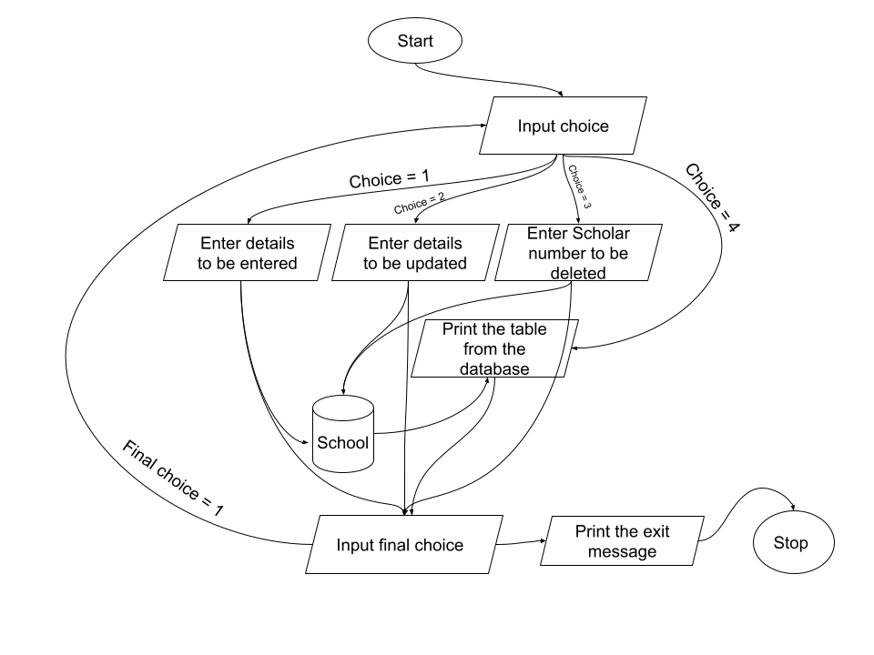

**Results and Output Images**

The project works fine and we're able to easily manage different details of students using Python And MySQL with the help of this program. Hence this program will be helpful for office purposes of different schools and organizations it will be helpful by providing

* Easier time management
* Efficiency
* Faster response
* Easy interface

MySQL proves to be really helpful for the DataBase Management part due to the following reasons:

**1. Scalability and Flexibility**

The MySQL database server provides the ultimate in scalability, sporting the capacity to handle deeply embedded applications with a footprint of only 1MB to running massive data warehouses holding terabytes of information. Platform flexibility is a stalwart feature of MySQL with all flavors of Linux, UNIX, and Windows being supported. And, of course, the open source nature of MySQL allows complete customization for those wanting to add unique requirements to the database server.

**2. High Performance**

A unique storage-engine architecture allows database professionals to configure the MySQL database server specifically for particular applications, with the end result being amazing performance results. Whether the intended application is a high-speed transactional processing system or a high-volume web site that services a billion queries a day, MySQL can meet the most demanding performance expectations of any system. With high-speed load utilities, distinctive memory caches, full text indexes, and other performance-enhancing mechanisms, MySQL offers all the right ammunition for today's critical business systems.

**3. High Availability**

Rock-solid reliability and constant availability are hallmarks of MySQL, with customers relying on MySQL to guarantee around-the-clock uptime. MySQL offers a variety of high-availability options from high-speed master/slave replication configurations, to specialized Cluster servers offering instant failover, to third party vendors offering unique high-availability solutions for the MySQL database server.

**4. Robust Transactional Support**

MySQL offers one of the most powerful transactional database engines on the market. Features include complete ACID (atomic, consistent, isolated, durable) transaction support, unlimited row-level locking, distributed transaction capability, and multi-version transaction support where readers never block writers and vice-versa. Full data integrity is also assured through server-enforced referential integrity, specialized transaction isolation levels, and instant deadlock detection.

Python proves to be beneficial for the project because of the following reasons:

* Platform-independent
* Faster and more efficient
* Portable
* Support for relational database systems
* Easy to migrate and port database application interfaces
* Support for SQL cursors

**Following are some output images of the program in running condition:**

**1.**

**2.**

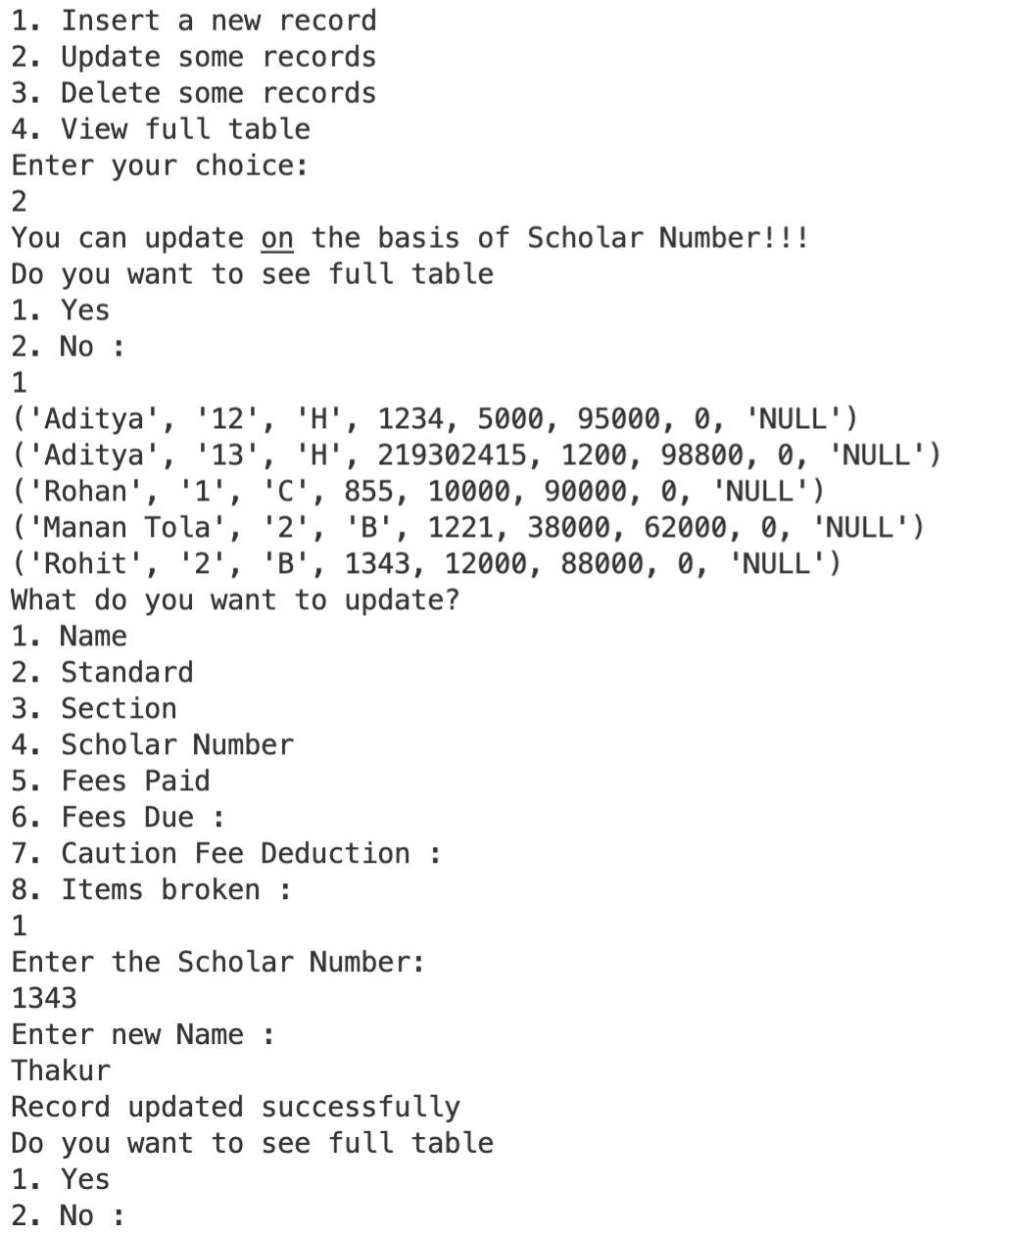

**3.**

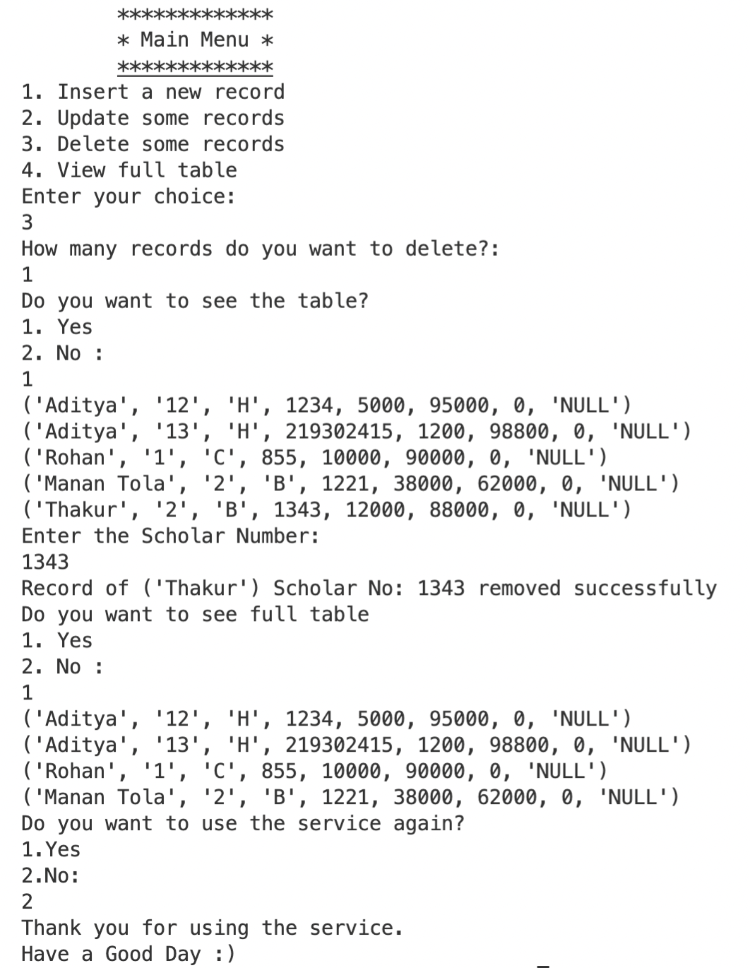

# 4.

# 

**CONCLUSION**

In this project, we developed an automated school management system that facilitates the various activities taking place at schools.

The system developed in the project consists of windows application. The windows application takes most of the activities such as fee information, caution money information, items broken (if any), class, section etc.

**Future Work:**

I am heading towards my next project of Movie Booking System where I’ll use MySQL and Python and with the help of multiple tables, I’ll be making an interface to book movie tickets.

**Recommendations:**

To enhance the efficiency of the system, in the following we have listed some recommendations and future works.

As education is central to development there should be a good facility to make stakeholders participate in school improvement programs and decision making. To facilitate easy information access to such bodies the web application could be further enhanced by incorporating additional reports required the Institution. Such facilities will increase participants in decision making at educational activities and students achievement.

We also believe that timetables should be flexible. In real world situations there are preferences. A restriction of the sort that every teacher should have some specific free periods or some part of days off requires an efficient search technique. Efficiency of the timetable could be further enhanced by improving the search technique so that such constraints as preferences could be taken into consideration.

# REFERENCES

* COMPUTER SCIENCE WITH PYTHON by SUMITA ARORA
* [www.python.org](http://www.python.org)
* [www.stackoverflow.com](http://www.stackoverflow.com)
* [www.stackexchange.com](http://www.stackexchange.com)
* [www.youtube.com](http://www.youtube.com)
* [www.wikipedia.org](http://www.wikipedia.org)
* <https://www.w3schools.com>

**Acknowledgements**

I would like to express my special thanks of gratitude to my project mentor Dr. Nirmal Kumar Gupta who gave me the golden opportunity to do this wonderful project – School Management System using Python and MySQL, which also helped me in doing a lot of research and I came to know about so many new things I am thankful to them.

Secondly, I would also like to thank my parents who encouraged me in my hard times and motivated me to pursue my project.

Also, my friends who helped me a lot in finalizing this project within the limited time frame and helped me whenever , where ever I got stuck in the process, and helped me in overcoming it.